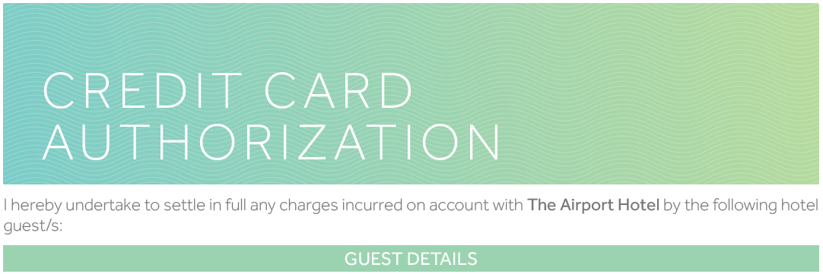

Guest Name: |  | Room Type:
Number of Adults: |  | Stay Package:
No. of Children (with Ages): |  | Total Amount:
Arrival Date: |  | Departure Date:
Arrival Time: |  | Departure Time:
Flight No.: |  | Flight No.:

☐ Charge Room Only to 3rd Party’s Credit Card.
☐ Charge Room and Food (Room Service) Only to 3rd Party’s Credit Card.
☐ Room Service up to QAR 100 ☐ Room Service up to QAR 200
☐ Room Service up to QAR 300 ☐ Room Service up to QAR 500
☐ Guest will pay his own room. 3rd Party’s Credit Card will only guarantee the room.
☐ Others (Please Specify): ___________________________________________
Card Holder Name: |  | Type of Card:
Contact Number: |  | Card No. (First 8 numbers)
Email Address: |  | Card No. (Remaining numbers)
Signature: |  | Card Expiration Date:
